NEW PRINCIPAL INSTITUTE 2013  Evaluation Onboarding: School Evaluation Profiles  Jen Kozin (jkozin@boston.k12.ma.us) - Data Analyst | 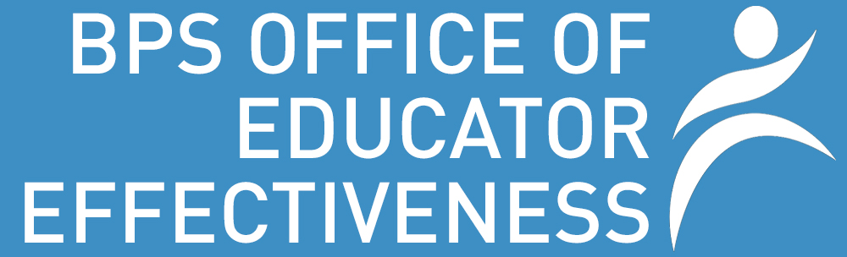

PURPOSE: This report shows the overview data collected in year one of implementation of the new educator evaluation system at your school. Use this question guide to look at the data and determine potential professional development opportunities and supports necessary for educators next year.

OVERALL STATS
Description: This section shows the total number of observations, artifacts, and evaluations entered for the school year. By May 15th, both formative and summative completion should have been at 100%.

Questions:
- Given the size of your school, does this seem like a reasonable number of observations and artifacts?

- Did all educators that were supposed to receive a formative and summative evaluation? If not, what are the potential implications for next year?

SELF-ASSESSMENT DATA
Description: At the beginning of the year, educators are asked to select at least one strength and area of growth tied to an element on the Rubric of Effective teaching. Educators could select anything they wanted to as the self-assessment did not require evaluator approval.

Questions:
- Looking at the elements self-assessed as strengths, are there particular areas where educators at your school feel that they are strong?

- How does your school’s self-assessed strengths compare with the district trend overall? Why might they be similar or different?

- Looking at the elements self-assessed as areas of growth, are there particular areas where educators at your school feel that they need to develop?

- How does your school’s self-assessed areas of growth compare with the district trend overall? Why might they be similar or different?

- How could you use this information to inform how you support educators at your school next year?

GOAL DATA
Description: All educators are required to have at least one professional practice goal and one student learning goal for each plan. The professional practice goal is tagged to an indicator on the Rubric of Effective Teaching and the student learning goal can be tagged to a specific assessment, subgroup of students, or subject area.

Questions:
- Are there particular areas that educators at your school identified for professional practice goals?

- Do the professional practice goals align with the areas self-assessed as areas of growth? If not, why might this be?

- How do your school’s professional practice goals compare with district trends? Why might they be similar or different?

- Are there particular areas of focus for student learning goals? If “Other”, what might these areas be?

- How do your school’s student learning goals compare with district trends? Why might they be similar or different?

EVALUATION DATA
Description: Formative assessments occur midway through the plan, and summative evaluations occur at the end of the plan. Educators on 2-year plans will have a formative evaluation at the end of year 1 of the plan. On each evaluation, educators receive a rating on each of the 4 standards and overall.

Questions:
- Does the distribution of ratings vary from standard to standard? Is there a particular standard that educators performed well in or may need work in?

- How does the rating distribution at your school compare with that of the district? What might this mean for your school?

- How does the rating distribution on formatives compare to summatives? Why might they be similar or different?

OBSERVATION DATA
Description: When evaluators observe educators through the online system, they link their feedback to an element on the Rubric of Effective Teaching.

Questions:
- Are there particular areas of the rubric where observations were focused?

- How do the areas commonly observed compare to self-assessed areas of growth, professional practice goals, and evaluation ratings?

PRESCRIPTION DATA
Description: For any standards rated less than proficient, evaluators write a prescription tagged to an indicator on the rubric of effective teaching outlining what the educator should do to improve.

Questions:
- Are there particular areas of the rubric where prescriptions at you school were focused?

- What supports might be necessary for educators with prescriptions on their plans at the start of next year?

OVERALL QUESTIONS
- How can you use the information in this report to plan for next year?

- What other data might be useful for you to have regarding educator evaluations?

