Instructions for Accessing the Educator Development & Feedback System (EDFS) and checking over staff rosters

Click on http://eval.mybps.org/evals/, which will bring you to a page that looks like this:
Log in using your HUB ID & password

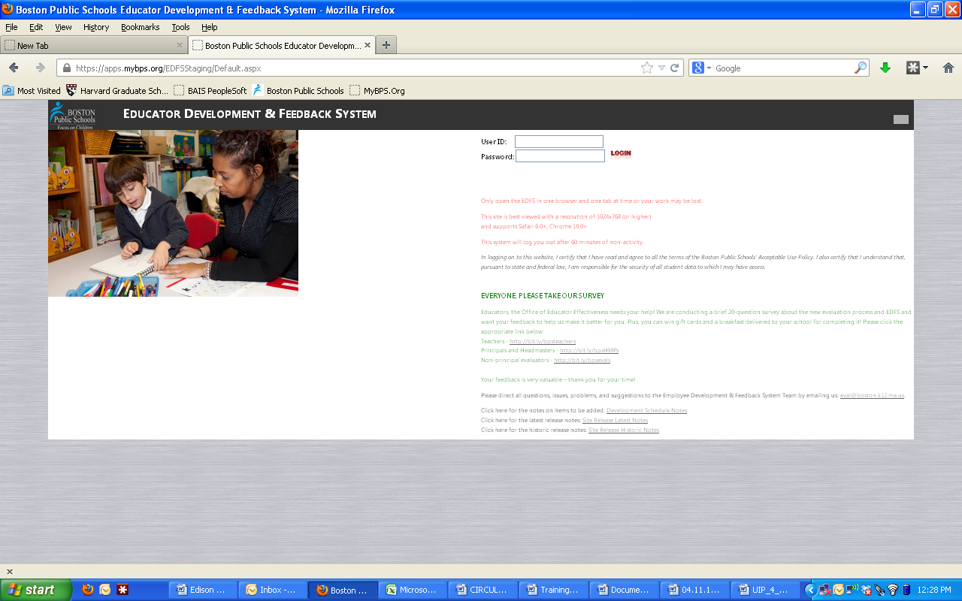

Once logged in you will need to do 3 things:
- Examine the non-licensed employees listed in your department and let us know if there is
  - Anyone missing
  - Anyone who is on your list but should not be
- Assign sub-evaluators to your non-licensed employees if necessary
- Enter performance evaluation ratings and submit paperwork to HR before the deadline
Once you are logged on, you will see a screen like the screen shot below. Be sure the toggle at the upper right corner of the screen (circled in red) says, “Manager.” To review the list of non-licensed employees assigned to your department click the tab at the top that says, “Assigned Evaluators for Non-licensed employees” and pull down to “All Non-licensed Employees” (circled in green)
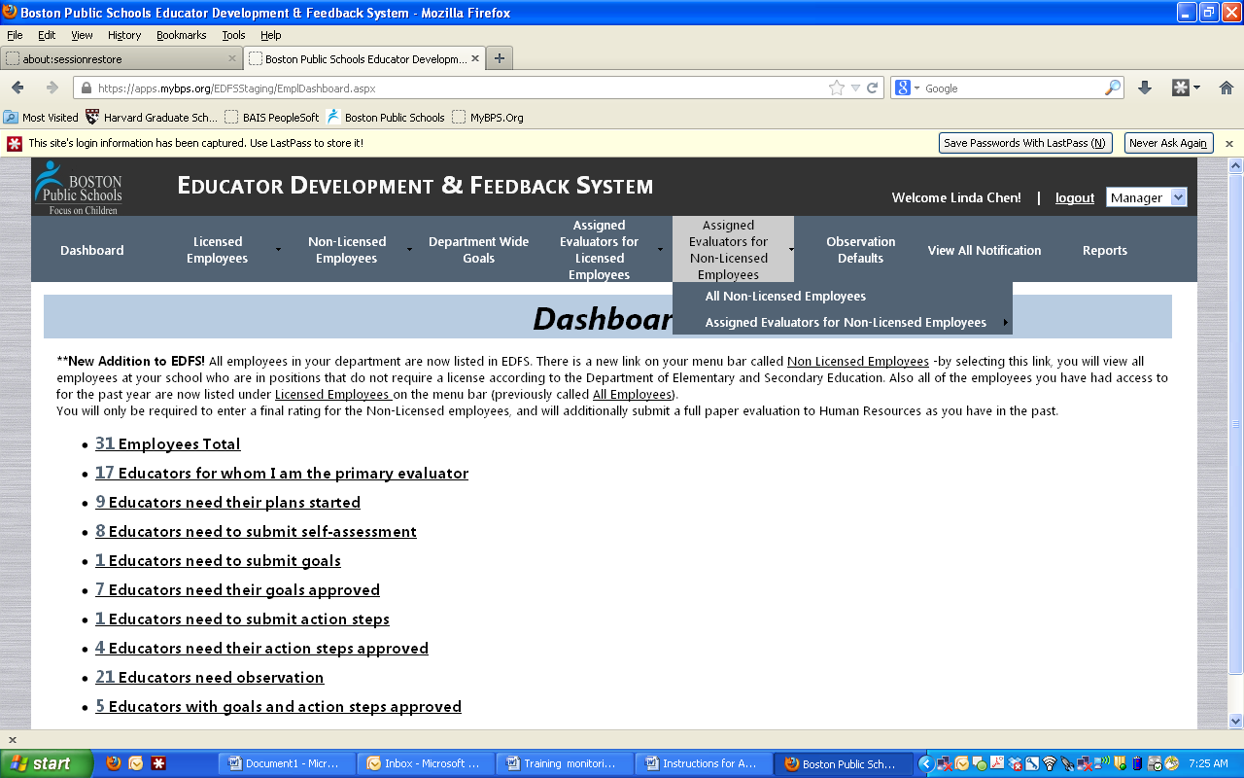

This will bring you to a page that looks something like the screen shot below. To the left of the screen you will see a list of employees in your department whom our records indicate either have been or are supervising other employees in your department (circled in red). We call these people sub-evaluators. To the right of the page you will see a list of non-licensed employees that our records indicate are working in your department (circled in green).

STEP 1: Examine the non-licensed employees listed in your department and let us know if there is anyone missing or anyone who is on your list but should not be
The first step you must take is to help us ensure that the list of non-licensed employees in your department is accurate. Please check the list to identify:
- Anyone who is on the list who should not be either because they no longer work for BPS or because they work for another department now
- Anyone who is not on the list but should be – so someone who you manage, who is not on the list.
If you identify anyone in either of these 2 categories please email or call David Glaser (at dglaser@boston.k12.ma.us or X5-6749) to get the list corrected
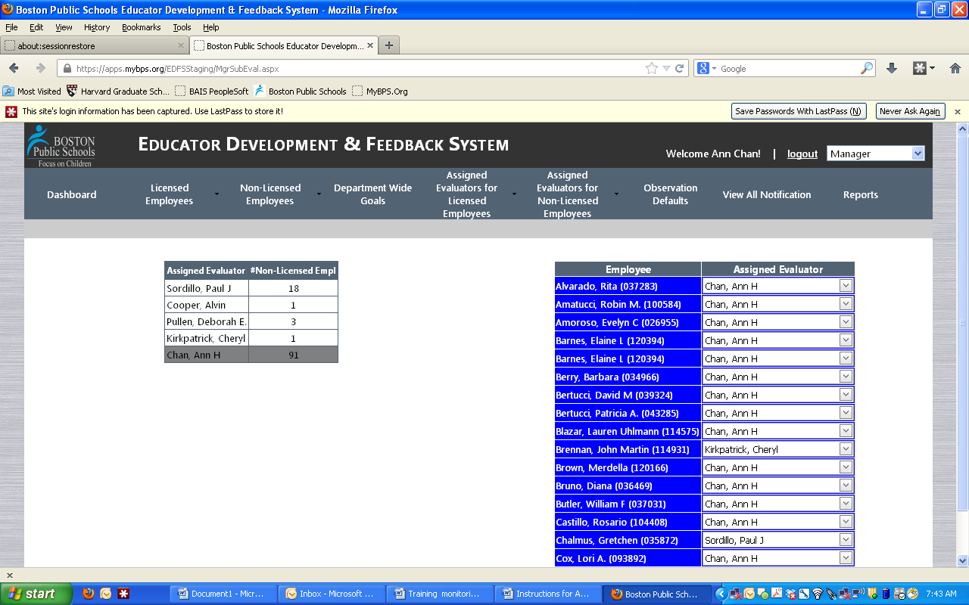

STEP 2: Assign sub-evaluators to your non-licensed employees as necessary
While on the same page you can assign sub-evaluators to your non-licensed employees, if you choose. To do this, click on the downward arrow to the right of the assigned evaluator currently associated with an employee (circled in red below), and select the sub-evaluator in your department who you would like to be responsible for that employee’s performance evaluation by clicking on the box in the column labeled, “Eval” and, if necessary, un-checking the box of the person who had been assigned to evaluate this person (circled in green below). If you want to assign more than one sub-evaluator to an employee, you can. You should ensure that at least one sub-evaluator has been designated as the “primary” evaluator by checking the box in that column (circled in orange below).
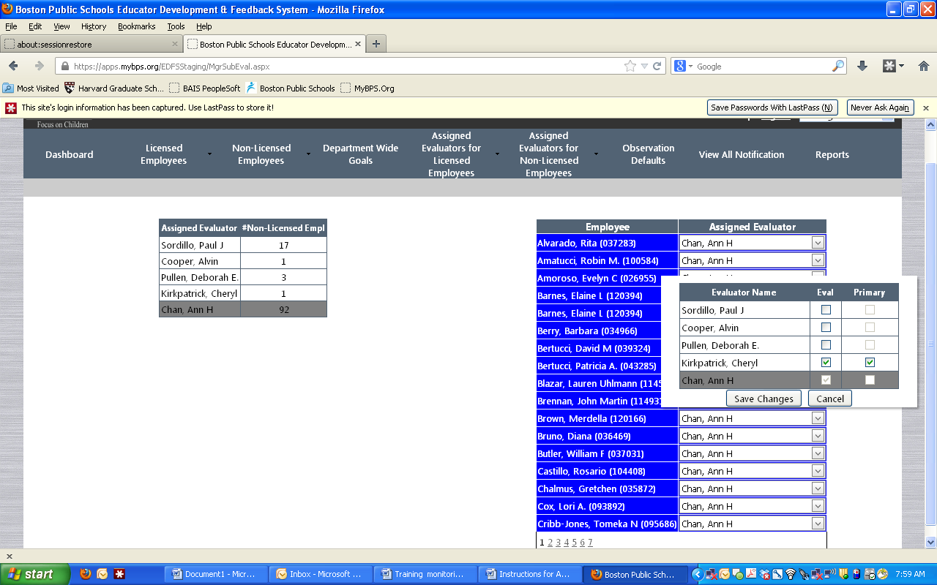
Check & un-check
If you would like to assign an employee a sub-evaluator who is not listed as one of your choices, you will need to contact HR to get the person added to your list of sub-evaluators. Once again, contact David Glaser (dglaser@boston.k12.ma.us or x5-6749)

Step 3: Enter performance evaluation ratings and submit paperwork to HR before the deadlines
Once your list is accurate and all of your employees are assigned to the right sub-evaluator you and your sub-evaluators will be able to enter the performance evaluation ratings for your employees in EDFS. Click on the tab at the top of the screen that says, “Non-licensed Employees” (circled in red) toggle to “Enter Overall Rating.” You will see a screen like the one below:
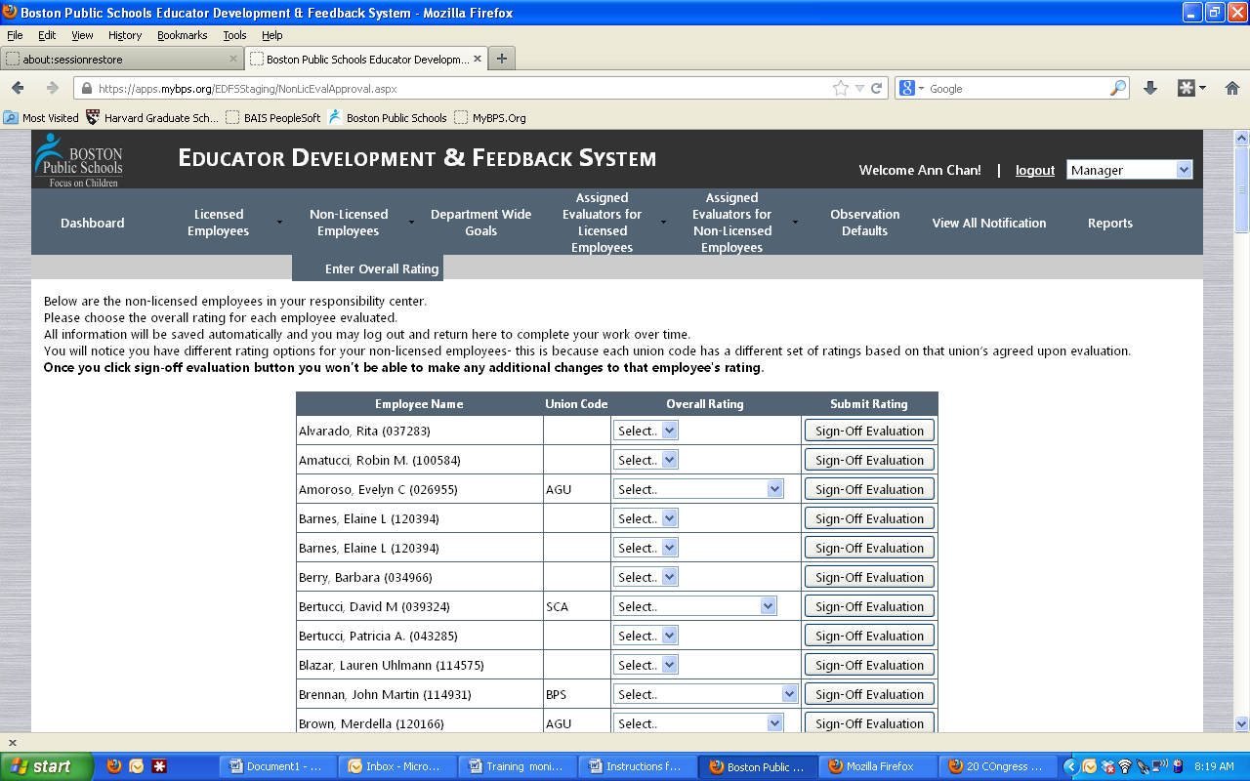
Click the arrow in the “overall rating” column (circled in green). Select the overall rating for that employee’s performance evaluation. Once the rating has been selected, click “Sign-Off Evaluation.”
Please be sure to send original, signed performance evaluations to HR to be filed.
HR needs to receive the original performance evaluation forms that you provide to your employees. These forms need to be signed. Please send them to Deborah Pullen (dpullen@boston.k12.ma.us) by the deadlines posted on MyBPS. We suggest you keep a copy of these forms for yourself, as well. Please be aware that we need BOTH the paper evaluation and the rating entered online to process step increases for many of your employees.

