An Example of a Formative Assessment
Overview Page - The formative assessment (or formative evaluation for 2 year Self-Directed Plans) has six distinct sections. The overview page allows you to move between these sections, as do the navigation buttons at the bottom of every section.
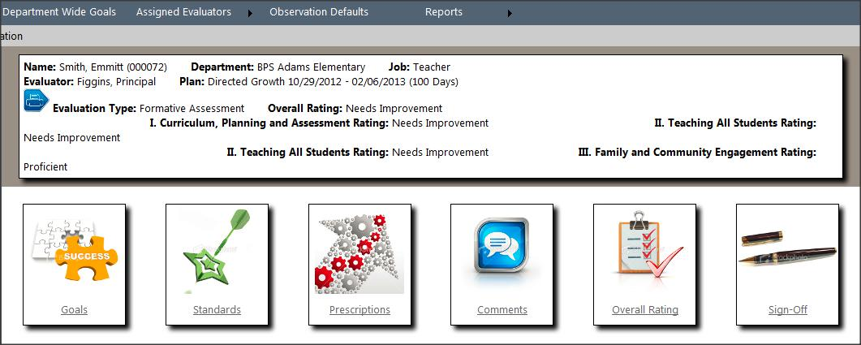
Goals Rating Page – Evaluators will provide a rating on the progress toward goals and a rationale to support the rating. Both the educator and the evaluator may view action steps associated with the goal by clicking the “View Action Steps” button on the left.
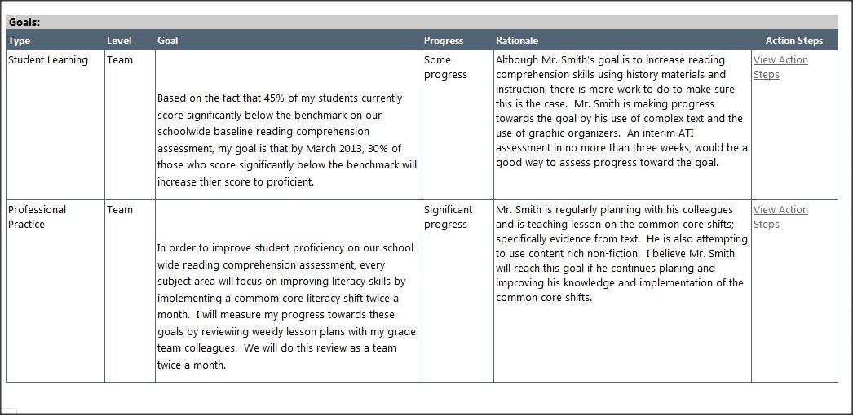

Standards Page: Rating on each Standard – The evaluator will rate the educator on each standard and provide a rationale to support.
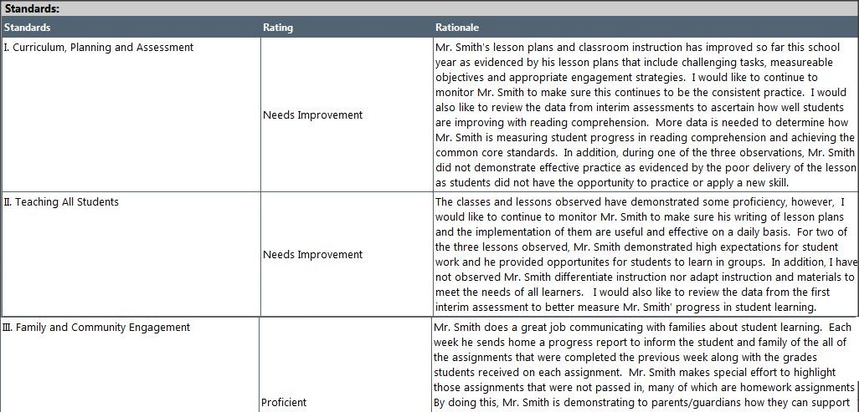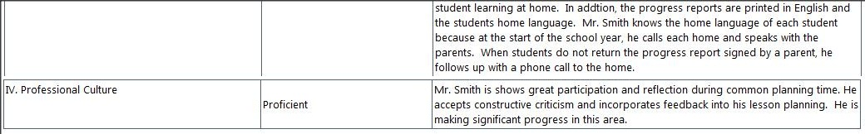
Standards Page: Plan Evidence - Artifacts and Observations are preloaded onto the webpage so that evaluators can view them as they rate an educator on the four standards. Both the artifacts and the observation evidence are filtered by standards.
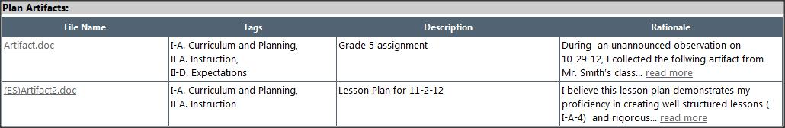
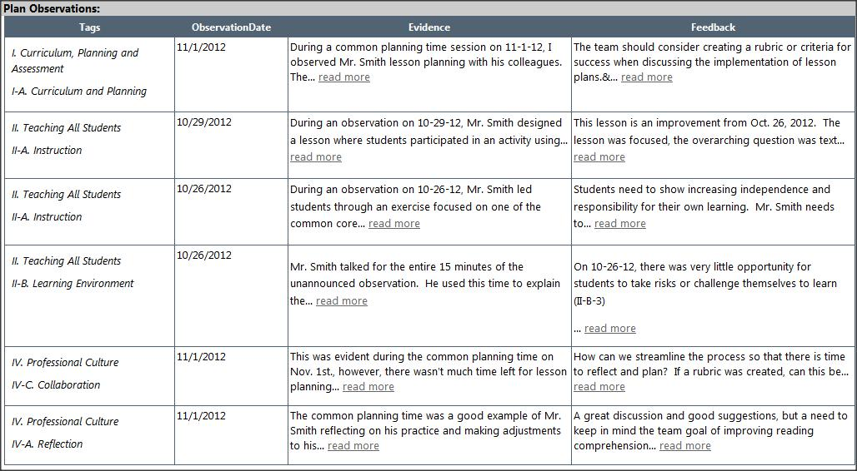
Prescriptions Page – If applicable, evaluators will write specific prescriptions for any standard rated less than proficient for the educator.
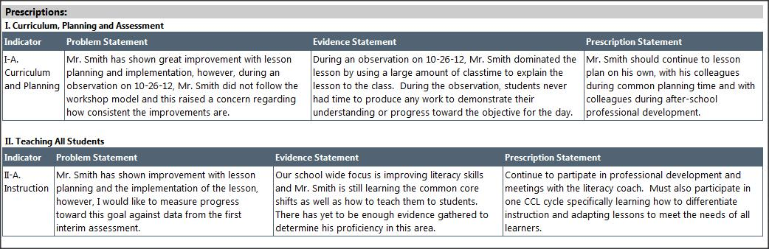

Comments Page – Both evaluators and educators can write comments about the formative assessment/evaluation on this page.
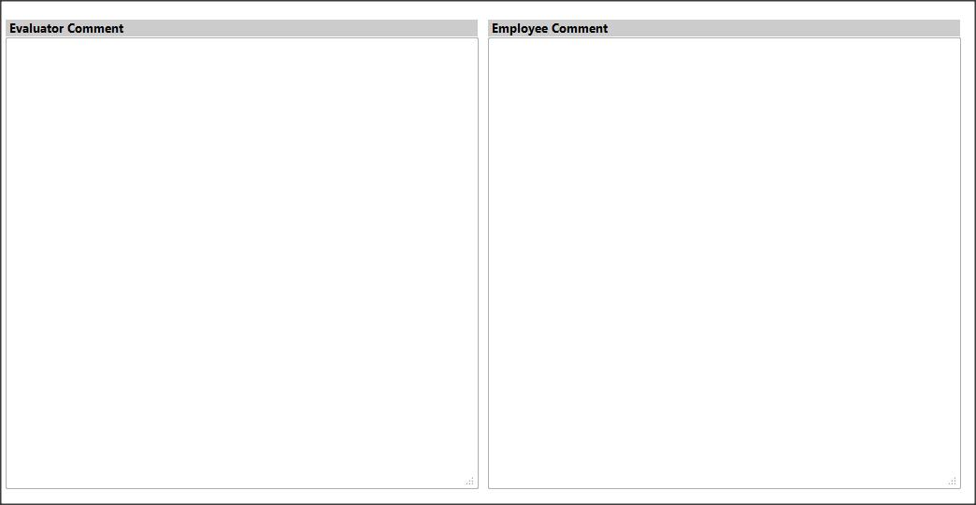
Overall Rating Page – Summarizes the ratings that the evaluator made on goals and standards.
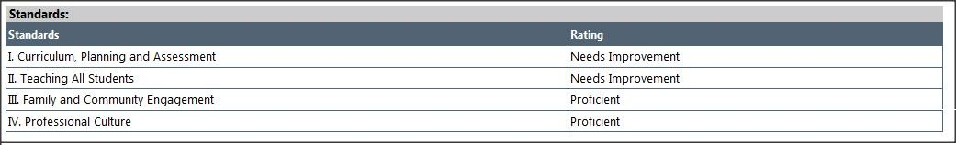
Sign-Off Page – Both the evaluator and the educator must “sign” the report. This sign-off is not meant to communicate that educators agree with the evaluation, but only that they have read and acknowledged it.
