Online Educator Development & Feedback System (EDFS)
Artifact Upload Guide
For teachers &other employees

- Principal Activates Plan
  - You will receive an email once your Principal/Headmaster has started your evaluation plan on the EDFS. You cannot submit your self-assessment until your plan has been activated.
- Login to the Educator Development & Feedback System:
  - Go to http://eval.mybps.org/ and login using the following information:
    - Username: Employee ID
    - Password: Current BPS Password
- Artifacts
  - Select the Artifacts link on your home page to provide evidence for your progress toward goals as well as the four standards:
  - Select Add Artifact on the left side of the screen:

  - The following text will appear on your screen:
1) Type a brief description of the evidence you are uploading.
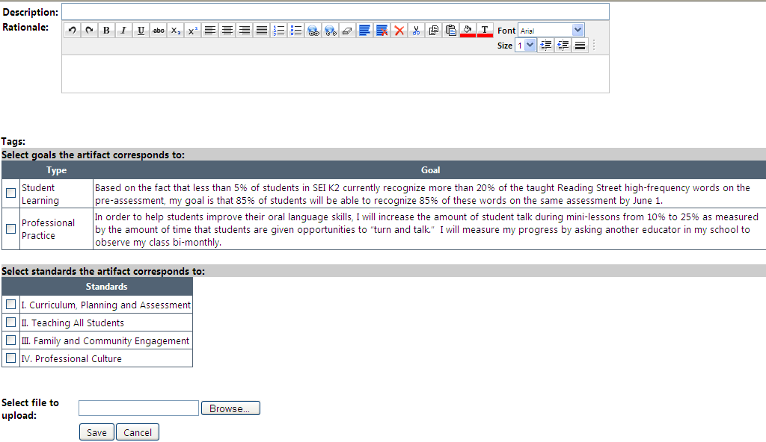
4) Select Browse, then choose which file from your desktop you would like to upload. Then select ‘Open’. Then select Save.
3) The evidence you are uploading should show your progress towards meeting your goals, or evidence towards meeting one of the standards. Select the check box next to the appropriate goal or standard.
2) Explain your rationale for choosing this item.

Example of completed Artifact page before selecting Save:
1) Entered Description
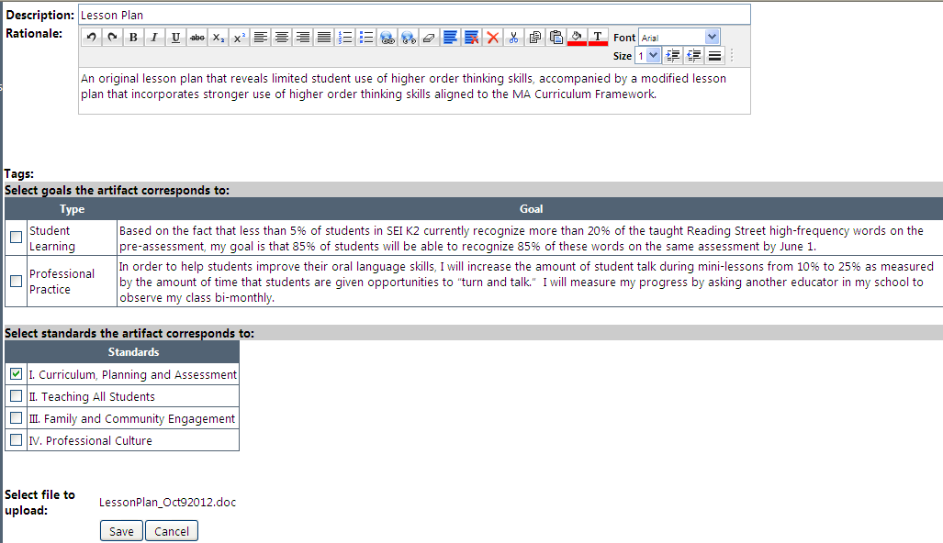
4) Uploaded File
3) Selected the Standard this Evidence is provided for (note this evidence was not connected to a goal, so no goal was selected.)
2) Explained Rationale
d. Once you have selected Save, you will view a summary of the uploaded artifact:
e. Continue adding as many artifacts as you would like. At least eight artifacts will be necessary for your evaluator to make informed ratings on standards and goals. You will be able to view artifacts your evaluator adds on this page as well.

