Educator Development and Feedback System (EDFS)
Practice Activity for Evaluators

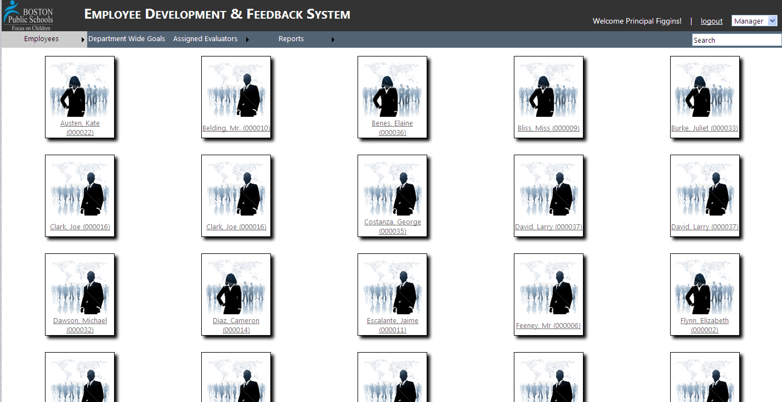

Directions

Use the following guides to practice using the Educator Development and Feedback System (EDFS) which is being used to evaluate all licensed educators school year 2012-2013

- In addition to this set of guidance documents, you will be given a piece of paper with the names/IDs of one teacher and one evaluator.

- Each of the following guides will ask you to login to the EDFS training site http://eval.mybps.org/training/ as either the assigned evaluator or the assigned teacher. This way, you will have an understanding of how you will use the EDFS as the evaluator, and also how your teachers are going to be using the website.
Educator Development and Feedback System (EDFS):
Creating Plans
For Evaluators

- Login to the TRAINING Educator Development and Feedback System:
  - Go to http://eval.mybps.org/training/ and login using the following information:
    - Username: Employee ID (Use the Evaluator’s employee ID you have been assigned)
    - Password: Password
- Choose an evaluation plan for your teacher:
Note: If you are a Principal/Headmaster with additional evaluators (such as APs) then you will also have to assign evaluators to each of your teachers. In this activity, Principal Figgins has already assigned teachers to evaluators.
  - Place the cursor over the Employees button on the top, left-hand side of your screen.
  - Select Needs Plan from the drop-down menu.
  - All of your teachers with unassigned plans will be listed for you. Select the teacher’s name/icon to which you have been assigned for this activity.
  - Select “Start Plan” and the following screen will appear:
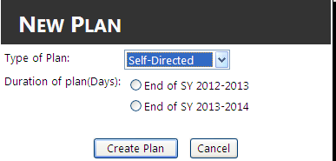
Select the teacher’s evaluation plan from the drop-down menu
Select the duration of the plan
Select “Create Plan”
- Teacher inputs goals:
  - Once you have assigned an evaluator and created an evaluation plan for the teacher, the teacher will receive an email prompting him/her to logon to the evaluation site to input his/her self-assessment and goals.
  - Next, you will logout as the Evaluator and move onto the next guide.

Online Educator Development & Feedback System (EDFS)
Self-Assessment Guide
For Teachers

- Login to the TRAINING Educator Development and Feedback System:
  - Go to http://eval.mybps.org/training/ and login using the following information:
    - Username: Employee ID (Use the Teacher’s employee ID you have been assigned)
    - Password: Password
- Self Assessment
  - Select the Self-Assessment link on your home page:
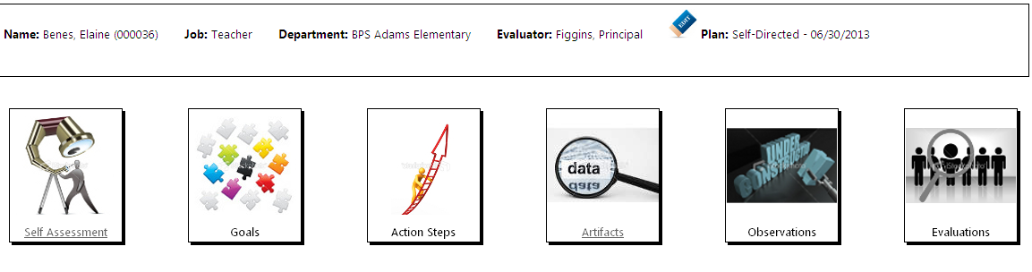
In this section of EDFS, you will enter your areas of professional strength and growth. You will also select the Element of the rubric to which these areas of strength/growth are connected.
  - Select Add Strength to submit a professional strength you have identified in yourself:
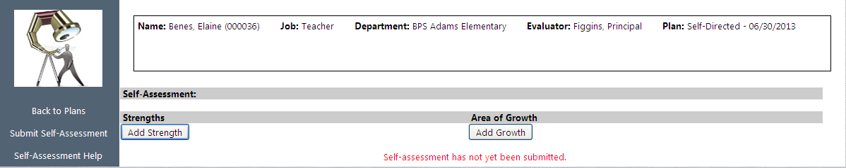

    - The following pop-up text box will appear on your screen:

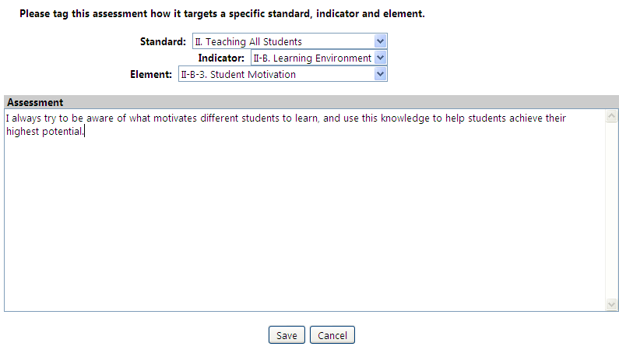
1) Select the Standard, Indicator, and Element within the Rubric that to which your strength is most connected.
2) Enter the assessment of your strength into this text box.
3) Select Save.

  - Select Add Growth to submit an area of professional growth you have identified in yourself:
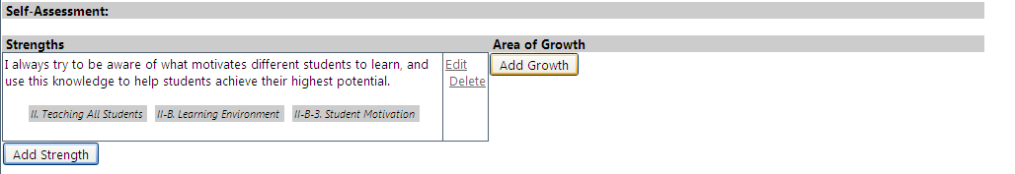

    - The following pop-up text box will appear on your screen:
1) Select the Standard, Indicator, and Element within the Rubric that to which your area of growth is most connected.
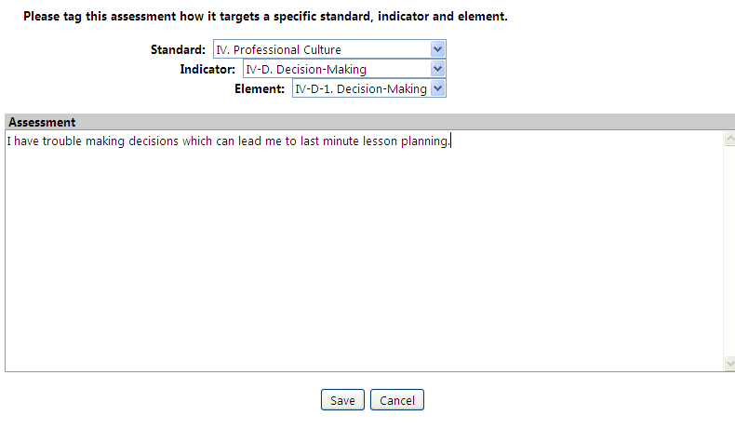
2) Enter the assessment of your area of growth into this text box.
3) Select Save.

  - Repeat steps b and c to add additional strengths and areas of growth to your self-assessment.
  - Once you have added all of your strengths and areas of growth, submit your self-assessment to your evaluator by selecting Submit Self-Assessment:
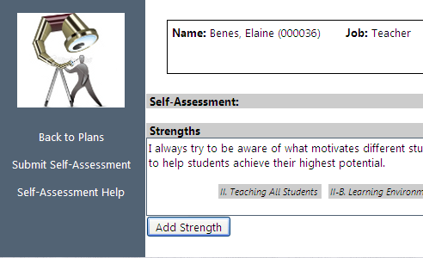
  - After selecting Submit Self-Assessment, you will select Yes on the following pop-up box:
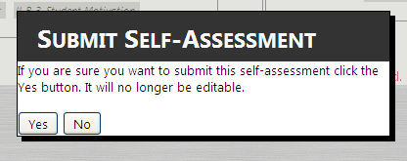
  - Now you are finished with your self-assessment and can begin creating your goals!

Online Educator Development & Feedback System (EDFS)
Goal-Setting Guide
For Teachers

- Login to the TRAINING Educator Development and Feedback System:
  - Go to http://eval.mybps.org/training/ and login using the following information:
    - Username: Employee ID (Use the Teacher’s employee ID you have been assigned)
    - Password: Password
- Goals
Note: You must first submit your self –assessment before submitting your goals. The Goals icon will not become active until the self-assessment has been submitted.
  - Select the Goals link on your home page.
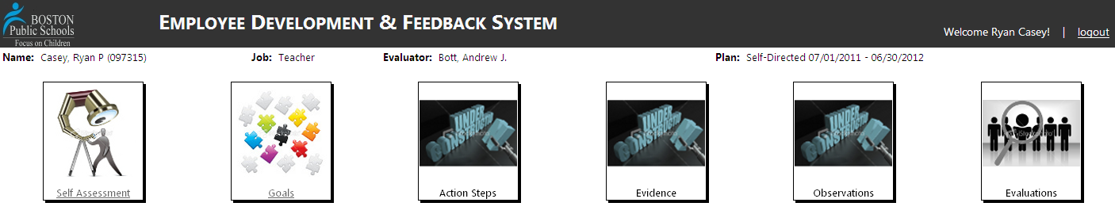
  - Select Create New Goal:
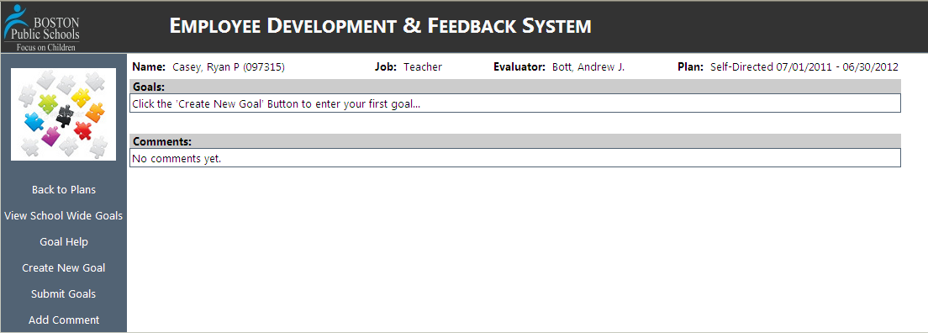

  - Fill in the following information from the pop-up box:
Select whether this goal is a Student Learning goal or a Professional Practice goal.
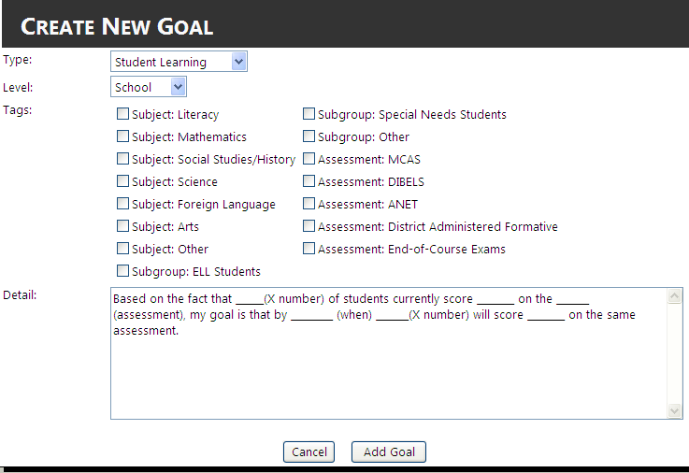
Select whether this is a school goal, team goal or an individual goal.
Select any subjects/ subgroups/assessments to which your goal applies.
Type your specific goal here for your principal’s review
Select Add Goal

  - Repeat steps 3) b. and 3) c. until all of your Goals have been added. (Reminder: You need to have at least one professional practice goal and one student learning goal).

  - Once you have added all of your goals, select Submit Goals on the left side of your screen to notify your Principal/Headmaster that you have entered your goals and are waiting for his/her approval:

Educator Development and Feedback System (EDFS):
Approving/Reviewing Goals
For Evaluators

- Login to the TRAINING Educator Development and Feedback System:
  - Go to http://eval.mybps.org/training/ and login using the following information:
    - Username: Employee ID (Use the Evaluator’s employee ID you have been assigned)
    - Password: Password
- Approve/Review your teacher’s goals:
Note: In order to Review your teacher’s goals, the teacher would need to have already submitted their self-assessment and goals into the EDFS.
  - Place the cursor over the Employees button on the top, left-hand side of your screen.
  - Select Goals Needing Approval from the drop-down menu.
  - Select the teacher’s name/icon. Note: Make sure this is a teacher you are assigned to evaluate
  - Select the Goals icon:

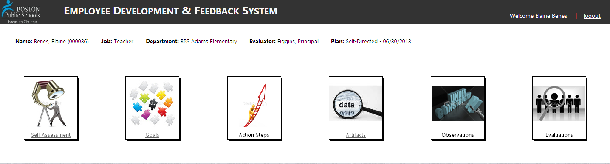

  - Review the proposed Student Learning and Professional Practice goals, and select Approve or Return for each:
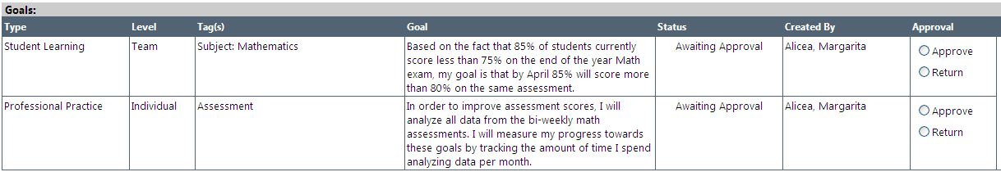

    - If you selected Return for either goal, then select Return Goals on the left hand side of the screen:
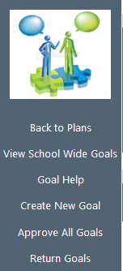
    - You will then be prompted to enter a message for the teacher, to explain why you are returning the goal(s). The teacher will receive an email and must re-submit his/her goal(s).
    - Once you want to approve both goals, you select Approve to the right of each goal and then select Approve All Goals on the left hand side of your screen.
    - If you want to return or approve all goals there is no need to select Approve or Return for each goal. Just click Approve All Goals or Return Goals.

  - Once you have selected Approve All Goals, the teacher will receive an email and the evaluator/teacher can continue to collect and submit artifacts/evidence.

Online Evaluation System: Guide to Submitting Evaluations
For Evaluators

- Login to the TRAINING Educator Development and Feedback System:
  - Go to http://eval.mybps.org/training/ and login using the following information:
    - Username: Employee ID (Use the Evaluator’s employee ID you have been assigned)
    - Password: Password
- Create New Evaluation
  - Select Employees located on the top, left-hand side of your Home Page
  - From the Drop-Down menu, select Goals Approved (Note: Goals must be approved to complete an evaluation)
  - Select the employee for whom you would like to submit an evaluation.
  - Select the Evaluations link:

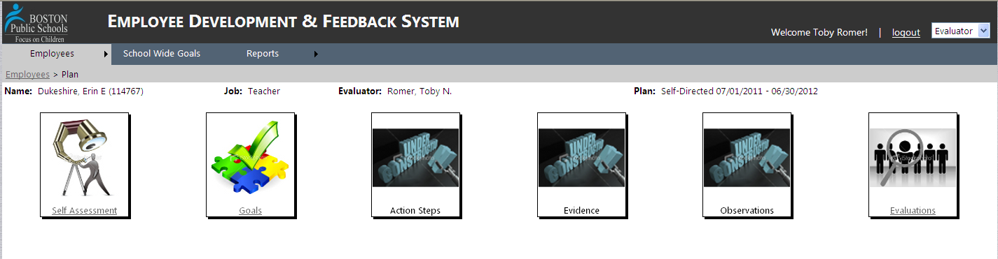

  - Select Start New Evaluation link on the left side of the screen
  - As a result, the following text box will appear in your screen:

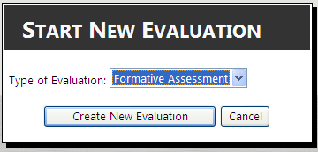
Step 1
Step 2

Step 1: Choose Formative Assessment, Formative Evaluation, or Summative Evaluation from
the drop-down menu
Step 2: Select Create New Evaluation

Note: In order to complete a teacher’s evaluation, you must complete each of the following, but they can be done in any order:
- Goal Progress Rating: Provide the teacher with a progress rating on each of his/her goals
- Standards Rating: Provide the teacher with a rating on each of the 4 standards for effective teaching
- Add Prescription: If any of the ratings (on goals, standards or overall) are “needs improvement” or “unsatisfactory,” provide the teacher with a rationale for the rating(s)
- Select Overall Rating: Provide the teacher with a rating that incorporates all multiple measures of effective teaching (goal ratings, standard ratings, artifacts, and student data) into an overall performance rating

- Goal Progress

  - Select the Goals icon:
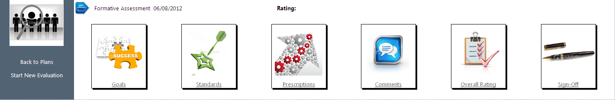
  - Next to each goal the educator proposed, select Progress Needed. Then:
Step 1: Select the progress that the educator made towards their goal: Exceeded, Met,
Significant Progress, Some Progress, Did Not Meet (Note: This is a change from previous
forms that only had three categories for progress)
Step 2: Input the rationale explaining how that educator made progress towards their goal (This
must be completed if the rating is “Did Not Meet”)

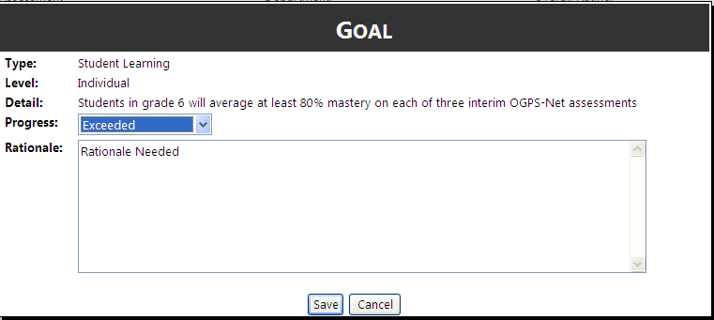
Step 1
Step 2
Step 3
Step 3: Save! This will save your rating, but you will still be able to change it anytime before
you have “signed off” on the evaluation
- Rate Standards
Either select the Standards link on the bottom right of the Goals page or select the Standards Icon on the Evaluation page
Step 1: Enter the employee’s Rating for each of the four Standards
Step 2: Explain this rating in the Rationale. (Note: You MUST provide a rationale if the Standard
is rated “Needs Improvement” or “Unsatisfactory.”)
Step 3: Then, Save the rating - you can change the rating or rationale at any point before you
“Sign off” on the evaluation

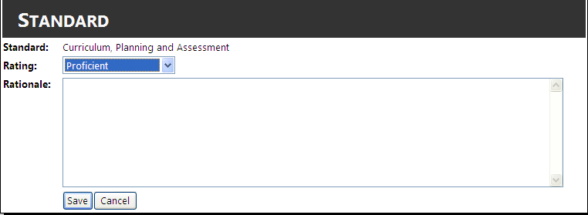
Step 1
Step 2
Step 3

- Add Prescription
Note: You only have to enter a Prescription for educators who are rated Needs Improvement or Unsatisfactory in one of the four Standards. If the educator is Proficient or Exemplary in all standards, you will not have to fill out a Prescription.

  - Once the Rating/Rational for all Standards have been listed, select the Prescriptions link on the bottom right of the Goals page (Note: You can also select the Prescriptions Icon on the Evaluation page)
  - Select Add New on the bottom right of the screen to add a Prescription
  - Enter the Indicator, Statement of Problem, Evidence, and Prescription (see steps 1-5 below) as prompted:
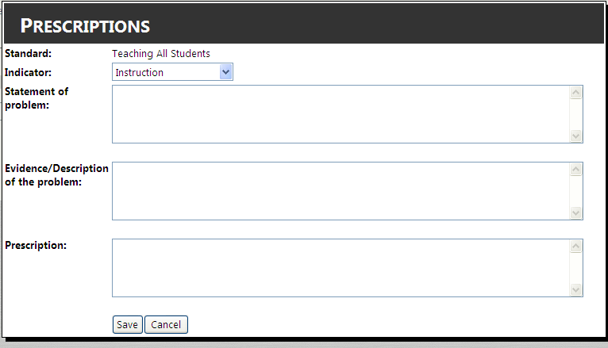
Step 1
Step 2
Step 3
Step 4
Step 5

  - Enter as many prescriptions as you deem necessary for this educator

- Add Comments
Note: This section is not mandatory to complete. If there are no relevant comments, you may leave this section blank.

  - Once the Prescriptions have been added, select the Comments link on the bottom right of the Prescriptions page (Note: You can also select the Comments Icon on the Evaluation page)
  - In the text box under Evaluator Comments, type any comments you may have

- Select Overall Rating
  - Select the Overall Rating link on the bottom right of the Prescriptions page or select the Overall Rating Icon on the Evaluation page)
  - View the summary of your Evaluation thus far, and use this information to select an Overall Rating for the educator at the top of the page:

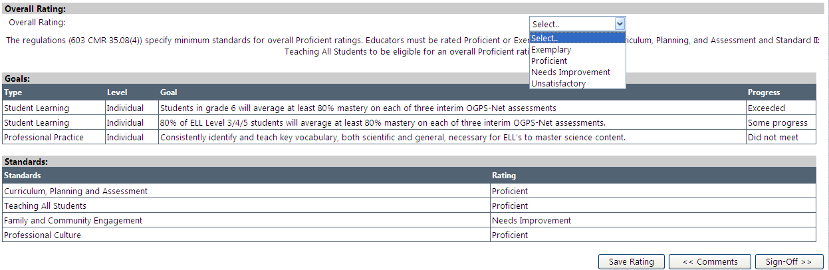

After you have chosen the rating, you can submit the rating by selecting Sign Off on the bottom right of the screen. Be aware that once you click “Sign Off” the evaluation is complete and will be sent to the teacher. It cannot be altered once you have signed off.

- Sign Off
  - Select the Sign Off link on the bottom right of the Overall Ratings page or select the Sign Off Icon on the Evaluation page)
  - If you are working on a Summative Evaluation, the current plan will automatically end. If you are working on a Formative Assessment or a Formative Evaluation, you will have the choice to continue with the current plan, or end the plan and start a new one:
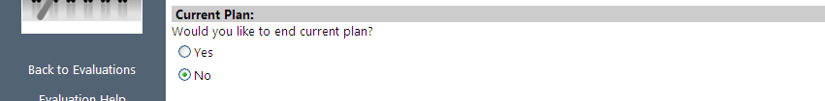\

  - Type your name into the text box to the right of the Evaluator Sign Off, then select the Signature Submit link:

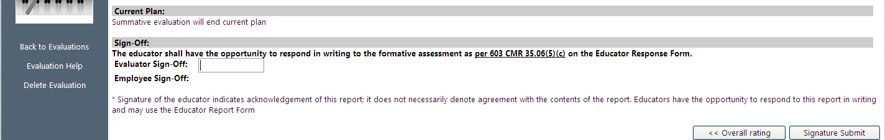
Step 1
Step 2

  - Once you submit your signature, the following text box will appear:
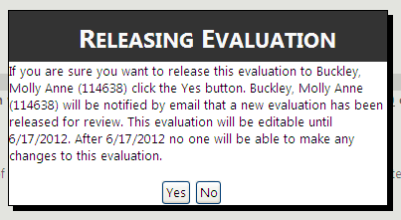
Select Yes if you are sure you want to Sign Off on this evaluation.

Additional Resources

- To visit the live EDFS site, visit:
https://eval.mybps.org/

- To gain additional guidance documents regarding educator evaluations, visit:
http://educatoreffectiveness.weebly.com/

- With additional questions about EDFS, contact Jenna Costin at jcostin@boston.k12.ma.us

