Online Evaluation System: Guide to Formative Assessments
For Evaluators

- Login to the Online Evaluation System:
  - Go to http://eval.mybps.org/evals/ and login using the following information:
    - Username: Employee ID
    - Password: Current BPS Password
- Create New Evaluation
  - Select Employees located on the top, left-hand side of your Home Page
  - From the Drop-Down menu, select All Employees
  - Select the employee for whom you would like to submit an evaluation.
  - Select the Evaluations link:
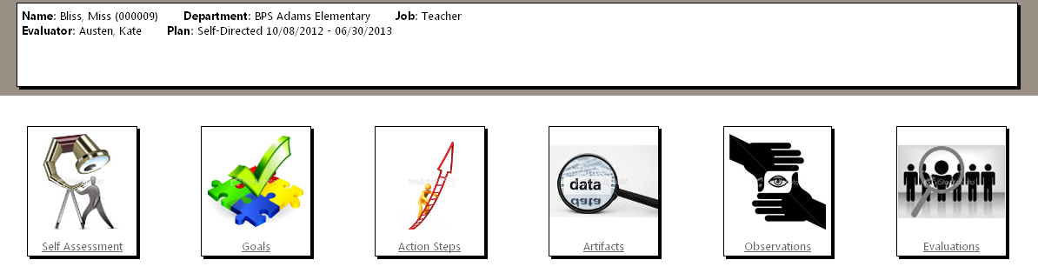
  - Select Start New Evaluation link on the left side of the screen
  - As a result, the following text box will appear in your screen:
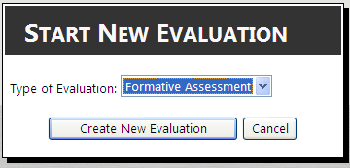
Step 1
Step 2
Step 1: Choose Formative Assessment from the drop-down menu
Step 2: Select Create New Evaluation
- Goal Progress
  - Select the Goals icon:
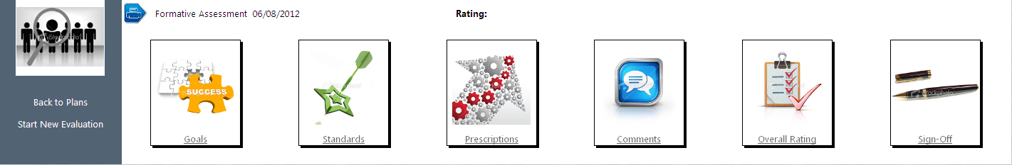
  - Next to each goal the educator proposed, select Progress Needed. Then:
Step 1: Select the progress that the educator made towards their goal: Exceeded, Met,
Significant Progress, Some Progress, Did Not Meet
Step 2: Input the rationale explaining how that educator made progress towards their goal
Step 3: Save! This will save your rating, but you will still be able to change it anytime before
you have “signed off” on the evaluation

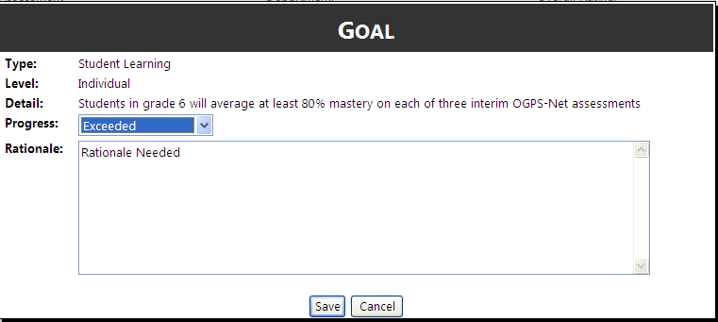
Step 1
Step 2
Step 3
- Rate Standards
  - Either select the Standards link on the bottom right of the Goals page or select the Standards Icon on the Evaluation page.
  - You will view the following form, asking you to rate the standards and also displaying Artifacts added to EDFS or Observations entered into the observation link on EDFS for this educator:
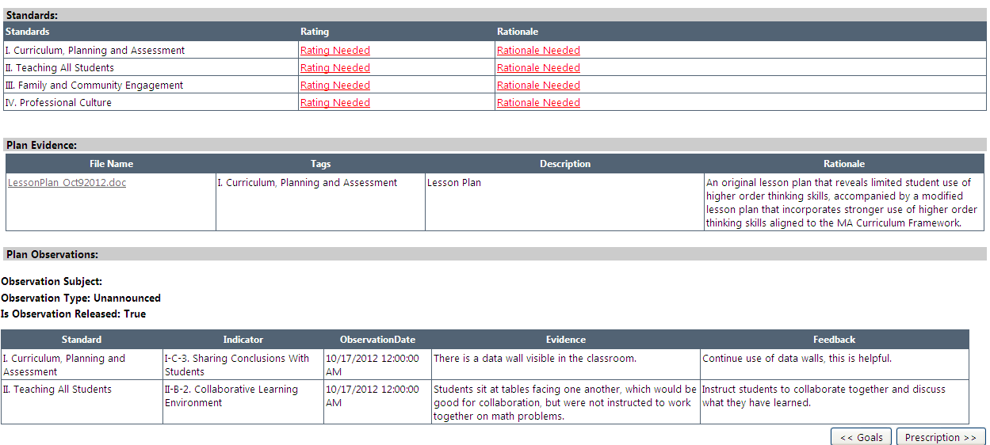
Step 1: Select ‘Rating Needed’ next to a standard, and select the appropriate rating from the drop down menu
Step 2: Explain this rating in the Rationale
Step 3: Save the rating
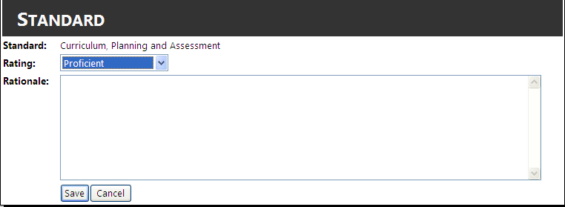
Step 1
Step 2
Step 3

  - Rate all four standards

- Add Prescription
Note: EDFS will only prompt you to enter a Prescription for educators who are rated Needs Improvement or Unsatisfactory in one of the four Standards. If the educator is Proficient or Exemplary in all standards, you will not have to fill out a Prescription.

  - Select the Prescriptions link on the bottom right of the Goals page (Note: You can also select the Prescriptions Icon on the Evaluation page)
  - Select Add New on the bottom right of the screen to add a Prescription
  - Enter the Indicator, Statement of Problem, Evidence, and Prescription (see steps 1-5 below) as prompted:
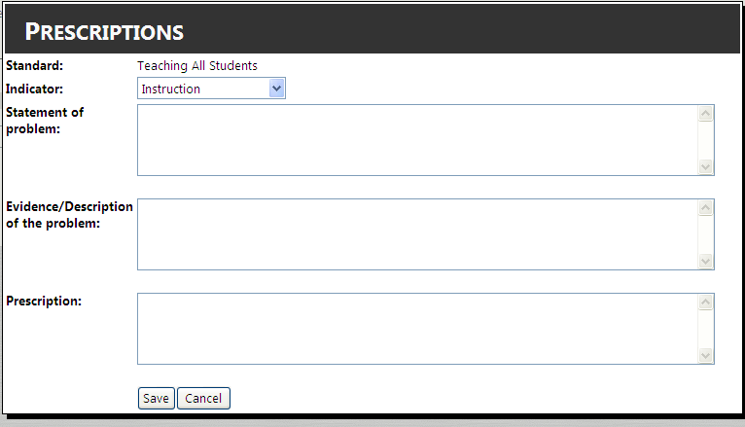
Step 1
Step 2
Step 3
Step 4
Step 5

  - Enter as many prescriptions as you deem necessary for this educator

- Add Comments
Note: This section is not mandatory to complete. If there are no relevant comments, you may leave this section blank

  - Once the Prescriptions have been added, select the Comments link on the bottom right of the Prescriptions page (Note: You can also select the Comments Icon on the Evaluation page)
  - In the text box under Evaluator Comments, type any comments you may have

- Select Overall Rating
  - Select the Overall Rating link on the bottom right of the Prescriptions page or select the Overall Rating Icon on the Evaluation page
  - View the summary of your Evaluation thus far, and use this information to select an Overall Rating for the educator at the top of the page:

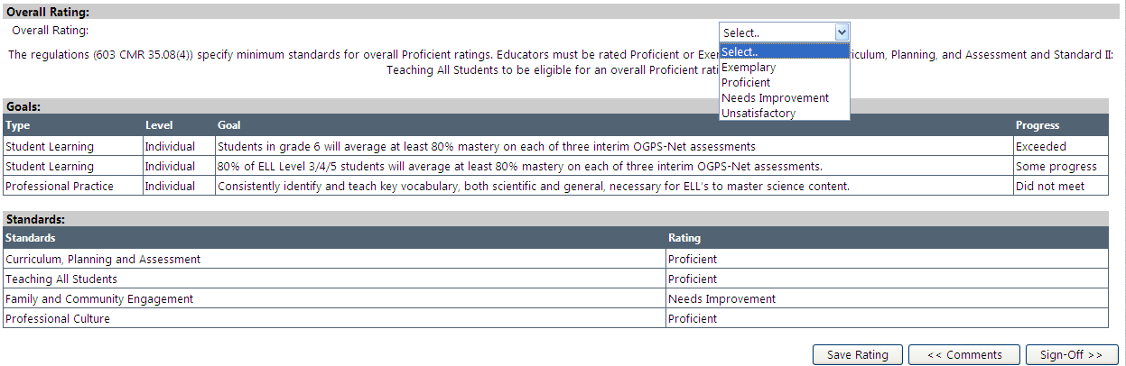

  - After you have chosen the rating, select Sign-Off on the bottom right of the screen (or on the main evaluation page)

- Sign Off
  - The top of the Sign-Off page will ask you if you would like to continue with the current plan, or end the plan and start a new one:
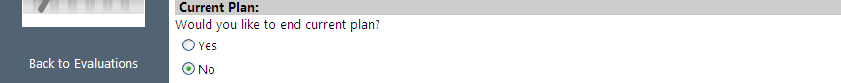
  - Next, type your name into the text box to the right of the Evaluator Sign Off, then select the Signature Submit link once you are sure the evaluation is complete. Once you select Signature Submit, an email will be sent to the employee and you will no longer be able to make edits.
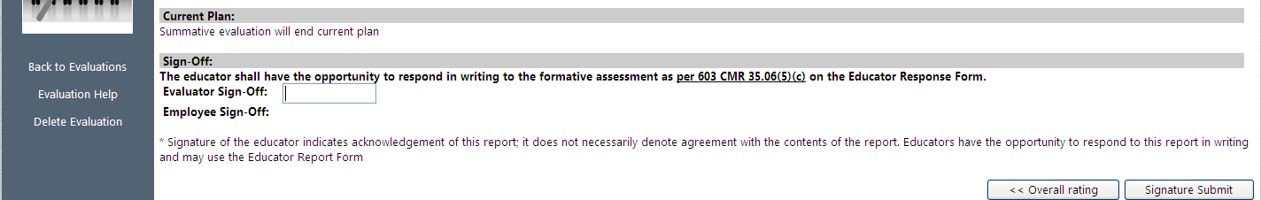
Step 1
Step 2
  - Once you submit your signature, a pop up box will appear asking you if you are sure you are ready to Sign Off on this evaluation. Select Yes if you are ready to Sign Off.

