Online Educator Development & Feedback System (EDFS)
Artifact Upload Guide
For Evaluators

- Login to the Educator Development & Feedback System:
  - Go to http://eval.mybps.org/ and login using the following information:
    - Username: Employee ID
    - Password: Current BPS Password
- Select an Employee
  - Once you login, you will see a list of your employees. Select the employee for whom you would like to add an artifact by scrolling through your list, or by typing his/her first or last name into the search function at the top right of your screen.

- Upload Artifact

  - Once you have selected the employee, you will see a summary of that employee’s evaluation plan thus far. Select the Artifacts icon for this employee:

  - Select Add Artifact on the left side of the screen:

  - The following text will appear on your screen:
1) Type a brief description of the evidence you are uploading.
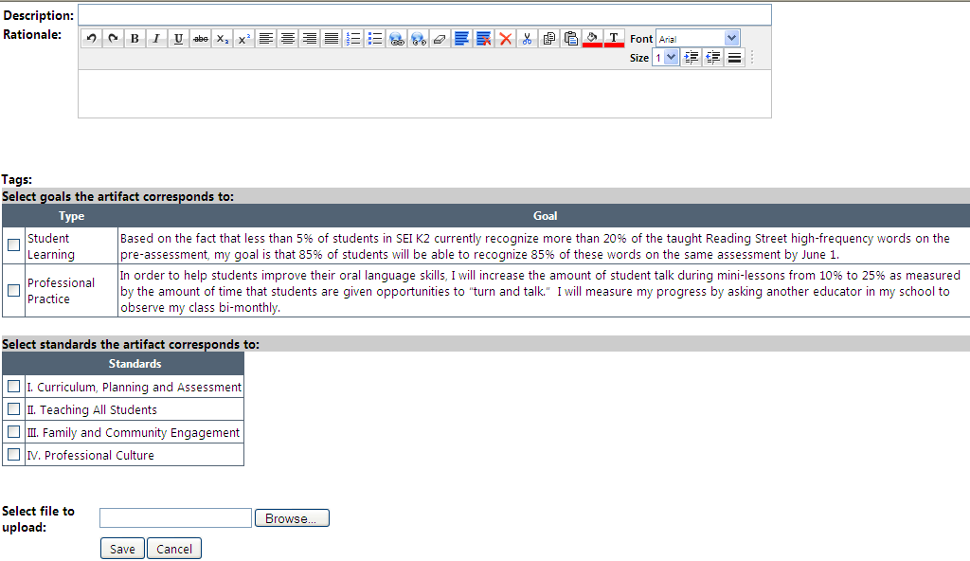
4) Select Browse, then choose which file from your desktop you would like to upload. Then select Open. Then select Save.
3) The evidence you are uploading should show this employee’s progress towards his/her goals, or evidence for one of the standards. Select the check box next to the appropriate goal or standard.
2) Explain your rationale for choosing this item.

Example of completed Artifact page before selecting Save:
1) Entered Description
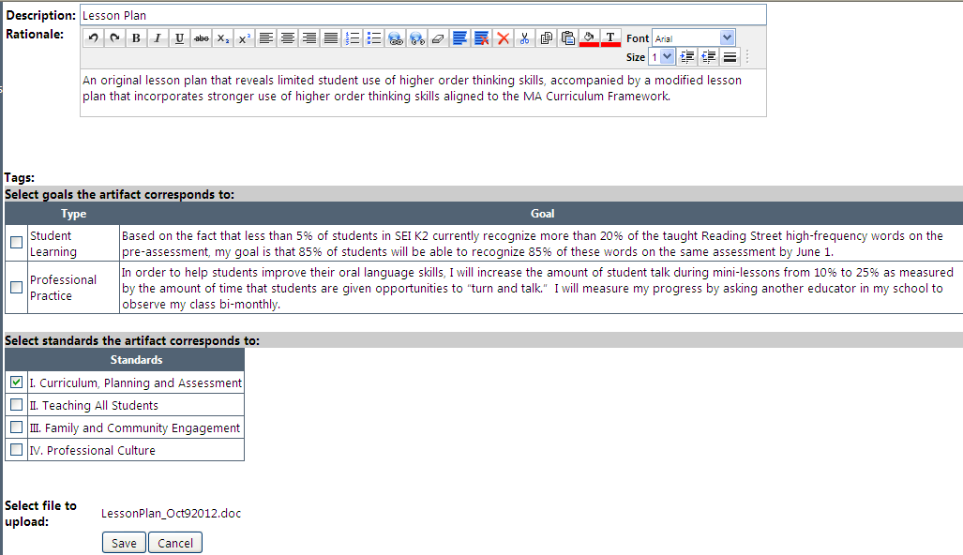
4) Uploaded File
3) Selected the Standard this Evidence is provided for (note this evidence was not connected to a goal, so no goal was selected.)
2) Explained Rationale
d. Once you have selected Save, you will see a summary of the uploaded artifact:
e. Continue adding as many artifacts as you would like for each employee. At least eight artifacts will be necessary for you to make informed ratings on your employees’ standards and goals. You will be able to view artifacts the employee adds on this page as well.

